Notes 11 - Confidence Intervals for Differences
STS 2300 Introduction to Data Analytics
Updated: 2026-04-19
Table of Contents
0.1 Reading for Notes 11 1
0.2 Learning Goals for Notes 11 1
1 Constructing confidence intervals for $p1-p2$ 2
1.1 Using a bootstrap distribution 2
1.2 Using theory-based methods 4
2 Constructing confidence intervals for $μ1-μ2$ 5
2.1 Using a bootstrap distribution 5
2.2 Using theory-based methods 6
3 Interpreting confidence intervals for differences 7
3.1 Situation 1 - Both endpoints are positive (or negative) 8
3.2 Situation 2 - One positive and one negative endpoint 9
4 Revisiting the Learning Goals for Notes 11 10

0.1 Reading for Notes 11
The reading for Notes 09 - 11 is interwoven throughout sections 8.4 - 8.7 of the Modern Dive textbook.

0.2 Learning Goals for Notes 11
- Be able to construct confidence intervals for differences in population proportions population means using bootstrap resampling (infer package) and using theory-based methods.
- Be able to accurately interpret confidence intervals for differences in population proportions and population means in context.

I’ll be using the following packages in this set of notes, so I’ll load them before I get started.
library(infer)
library(dplyr)
library(ggplot2)
library(palmerpenguins)

1 Constructing confidence intervals for $p_{1}-p_{2}$
Let’s revisit the example from Activity 10 of the dog attempting to smell COVID-19. In the activity, we only considered cases where COVID-19 was present, but we might want to know if the dog was equally accurate for cases with and without COVID-19 present. This would mean we are interested in the following parameter:
$p_{1}-p_{2}$ = the true proportion of positive cases the dog can correctly identify minus the true proportion of negative cases the dog can correctly identify

The code below reads the full data into R.
- The ID variable tells us whether the dog said the sample was positive or negative for COVID-19.
- The actual variable tells us whether the sample really was positive or negative
- We are creating a variable called correct that will say "yes" or "no" based on whether the dog’s ID matches reality

covid_dog <- data.frame(ID = c(rep("positive", 157), rep("negative", 792),
rep("positive", 33), rep("negative", 30)),
actual = c(rep("positive", 157), rep("negative", 792),
rep("negative", 33), rep("positive", 30))) |>
mutate(correct = ifelse(ID == actual, "yes", "no"))

1.1 Using a bootstrap distribution
When we want to create a bootstrap distribution for a difference, we will have a variable that splits our data into two groups. This variable will go after the ~ in the specify() function. We will also need to use the order argument inside calculate() to say the order of subtraction for our difference.
In cases where we are interested in a difference in population proportions, our bootstrap distribution code will have the following form:

boot_dist <- data |>
specify(formula = response ~ explanatory, success = "level") |>
generate(reps = 1000, type = "bootstrap") |>
calculate(stat = "diff in props", order = c("group 1", "group 2"))

In addition to changing boot_dist, data, response, and level like we did in the single proportion case, we will also need to make the following changes:
- explanatory – the variable splitting our data into two groups
- group 1 – explanatory variable category to be considered our first group
- group 2 – explanatory variable category to be considered our second group

Practice: Try applying this to the COVID-19 sniffing dog example. Use positive samples as your first group and negative samples as your second group. (Note: I used seed 112300. You can use the same one to recreate my graph or choose your own to see how the graph and your corresponding intervals differ.)

set.seed(___)
dog_boot <- ___ |>
specify(formula = ___ ~ ___, success = "___") |>
generate(reps = 1000, type = "bootstrap") |>
calculate(stat = "___", order = c("___", "___"))
visualize(___)
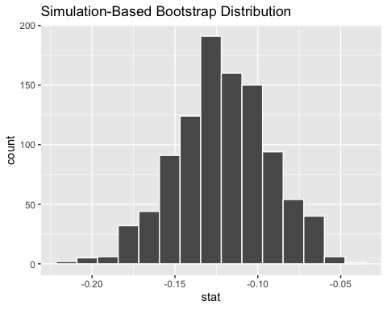

This bootstrap distribution represents 1,000 differences in sample proportions. Because my first group was positive samples and my second group was negative samples, the negative numbers I see mean the dog correctly identified a higher proportion of times when COVID-19 was not present than when it was. (Note: We will revisit this in more detail when we talk about interpreting intervals for differences.)
Just like in the previous chapter, I can use the percentile or standard error methods with the get_ci() function to calculate my confidence interval for $p_{1}-p_{2}$.

Practice: Calculate a 99% confidence interval using the percentile method.
99% confidence interval:

1.2 Using theory-based methods
The prop.test() function can be used to calculate theory-based confidence intervals for a difference in proportions. The function will require us to specify the same three arguments (x, n, conf.level) that we did for a single proportion. However, now x and n will both be vectors of length 2. We can use the c() function to enter the numbers as a vector. In other words:
- x will consist of the number of successes for both groups
- n will consist of the sample size for each group

Practice: I’ve used the table() function to help find values for x and n. Use the results to make a 99% theory-based confidence interval for the difference in the proportion of correct identifications between samples with and without COVID-19.

table(covid_dog$correct, covid_dog$actual)
##
## negative positive
## no 33 30
## yes 792 157

99% confidence interval:
Remember that theory-based methods have assumptions that must be met for the intervals to be valid. For the interval for the difference in proportions, we have the following assumptions:
- The data is a random sample.
- The sample size is “large enough” for both groups (usually at least 5 successes and 5 failures).

2 Constructing confidence intervals for $μ_{1}-μ_{2}$
For this example, we will revisit the penguins data from the palmerpenguins package. In Notes 10, we looked at the population mean bill length of Antarctic Penguins. Here we will compare the population mean bill length between female and male Adelie penguins.
The code below creates a data frame called adelie that subsets the penguins data from the palmerpenguins package to only include Adelie penguins and to remove all penguins missing information on their sex.

adelie <- filter(penguins, species == "Adelie",
!is.na(sex))

2.1 Using a bootstrap distribution
In cases where we are interested in a difference in population means, our bootstrap distribution code will have the following form:

boot_dist <- data |>
specify(formula = response ~ explanatory) |>
generate(reps = 1000, type = "bootstrap") |>
calculate(stat = "diff in means", order = c("group 1", "group 2"))

From this template, we will need to make the following changes:
- boot_dist – replace with name for our object (if desired)
- data – replace with name of our data frame we are using
- response – replace with our quantitative variable of interest
- explanatory – replace with our categorical variable that determines our two groups
- group 1 and group 2 – replace with the two categories we are comparing
Practice: Fill in the blanks below to create a bootstrap distribution for a difference in population mean bill length between male and female Adelie penguins.
set.seed(___)
adelie_boot <- ___|>
specify(formula = ___ ~ ___) |>
generate(reps = 1000, type = "bootstrap") |>
calculate(stat = "___", order = c("___", "___"))
visualize(___)
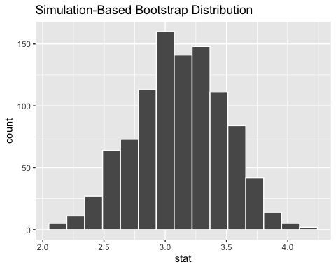
This bootstrap distribution represents 1,000 differences in sample means. Because my first group is male and my second group is female, positive numbers mean male penguins had a higher mean bill length than female penguins.
As with our other examples, I can use the percentile or standard error methods with the get_ci() function to calculate a confidence interval for $μ_{1}-μ_{2}$.

Practice: Calculate a 90% confidence interval using the SE method. (Note: Remember you will need to first calculate your point estimate.)
90% confidence interval:

2.2 Using theory-based methods
The t.test() function, which we used to calculate theory-based confidence intervals for a mean, can also be used for differences in means. There are two ways we can use the function.
- Option 1 specifies our data frame in a data argument then references the column names in the formula notation.
- Option 2 ignores the data argument and instead uses $ notation to directly reference the vectors for our two variables.
# Option 1
t.test(response ~ explanatory, data = dataname)
# Option 2
t.test(dataname$response ~ dataname$explanatory)

Practice: Use t.test() to calculate a 90% theory-based confidence interval for the difference in population mean bill lengths for female versus male Adelie penguins.
Code / Answer:

Question: What is different about how these intervals compared to my bootstrap intervals above? Why do you think this happened? (Hint: Think about our groups)
Answer:

3 Interpreting confidence intervals for differences
When we’re interpreting an interval for a difference in two numbers, we have to consider whether our interval contains positive numbers, negative numbers, or a mix of the two. This is because the values within our interval represent differences.
Recall that:
- When a difference is positive, it indicates the first group being compared has the larger value
- When a difference is negative, it indicates the second group being compared has the larger value

Let’s start by considering an interval that contains all positive numbers or all negative numbers (instead of a mix of the two).

3.1 Situation 1 - Both endpoints are positive (or negative)
If our confidence interval has endpoints that are either both positive or both negative, we could give an interpretation like this:

Generic Interpretation: We are xx% confident that the population ___ is between ___ and ___ bigger for our group with the higher mean/proportion than for our group with the smaller mean/proportion

We will need to put this into context for each specific example.
My 90% confidence interval for the difference in Adelie penguin population mean bill lengths (male - female) was: (2.538, 3.727). Because all of the values in my interval are positive, I’m confident that males (group 1) have a longer population mean bill length than females (group 2). My interpretation would look like:

Diff in means interpretation in context: We are 90% confident that the population mean bill length for Adelie penguins is between 2.538 mm and 3.727 mm longer for male penguins than for female penguins.

Practice: Try writing an interpretation for our COVID-smelling dog example (positive - negative). My interval was (-0.2, -0.057). (Hint: First figure out which group we think the dog was better at identifying.)
Answer:

3.2 Situation 2 - One positive and one negative endpoint
In some cases, we might have a confidence interval where the lower endpoint is negative and the upper endpoint is positive. This suggests that we aren’t confident either group has a higher population mean/proportion. However, we can still provide context about how big any difference might reasonably be.

Generic Interpretation: We cannot be xx% confident that either group has a bigger population mean/proportion. However, we are xx% confident that the population __ is anywhere from __ bigger for group 1 to __ bigger for group 2.

Let’s revisit the penguin bill length example (male - female). Consider the following hypothetical confidence intervals.
- (-0.1, 0.2)

- (-4, 3)

- (-0.1, 5)

Question: How might our understanding of Adelie penguin bill lengths practically differ based on these three intervals?
Answer:

Practice: Pick one of these and write an interpretation in context of the example.
Interpretation:

4 Revisiting the Learning Goals for Notes 11
- Be able to construct confidence intervals for differences in population proportions population means using bootstrap resampling (infer package) and using theory-based methods.
- Be able to accurately interpret confidence intervals for differences in population proportions and population means in context.

